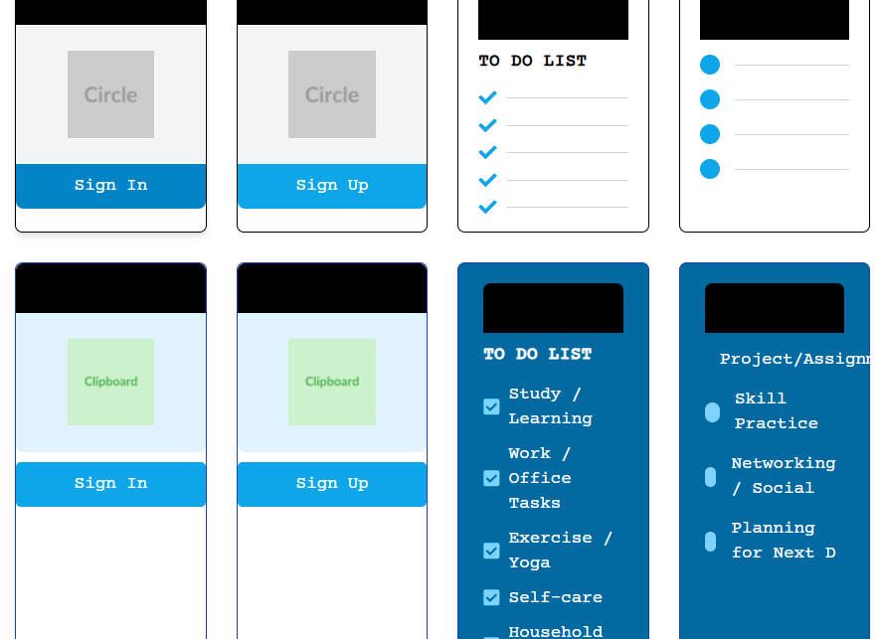

**FEEDBACKS**

* **Alignment Issues:** Some elements, especially the text and icons inside the list items, could benefit from more consistent vertical and horizontal alignment to improve visual balance and readability.
* **Icon Usage:** Adding more icons throughout the interface would enhance visual cues and user experience. Consider upgrading existing icons to more modern or colorful versions to make the interface livelier and more engaging.
* **Typography Touch:** While the Courier Prime font gives a unique style, mixing it with a clean sans-serif font for body text or smaller details could improve readability and hierarchy. Also, consider adjusting letter spacing and line height for better text flow.
* **List Customization:** The to-do lists could be enhanced with interactive elements such as hover effects, check/uncheck animations, or subtle color changes to indicate task status. Custom bullet points or icons for different task categories would add clarity.
* **Font Uniformity:** Ensure consistent font sizes and weights across similar elements (e.g., all buttons or all headings) to maintain a cohesive look. Some buttons and headings currently have slightly different sizes or spacing that can be unified.
* **Color Palette Consistency:** The blue tones used are pleasant but could be harmonized further by defining primary, secondary, and accent colors with consistent shades and saturation for a more polished appearance.
* **Spacing and Padding:** Increasing padding inside cards and between elements can reduce visual clutter and improve touch targets on mobile devices, enhancing usability.
* **Responsiveness:** While the layout is grid-based, testing on various screen sizes and adjusting breakpoints or stacking behavior can ensure the app remains user-friendly on smaller devices.